**Running microRTS in Eclipse**

Select File – New – Java Project

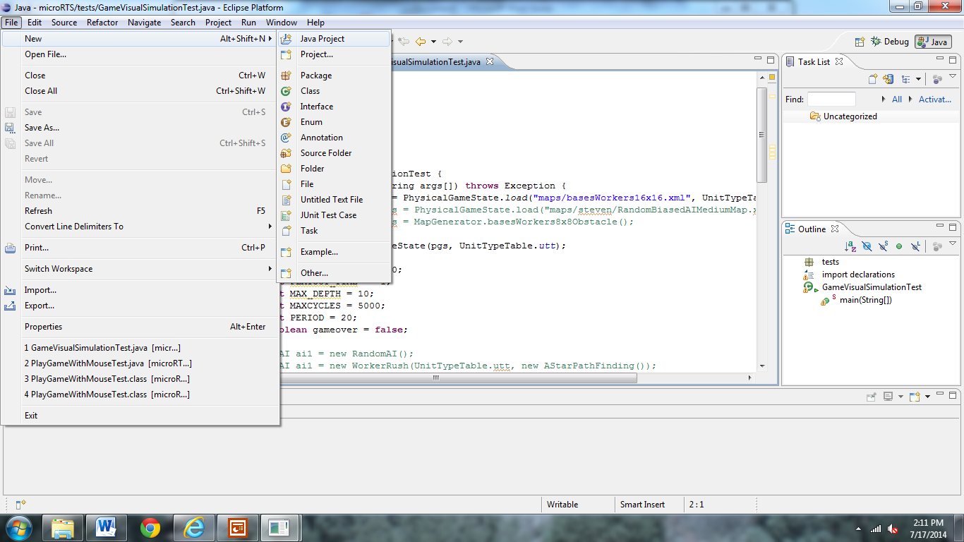

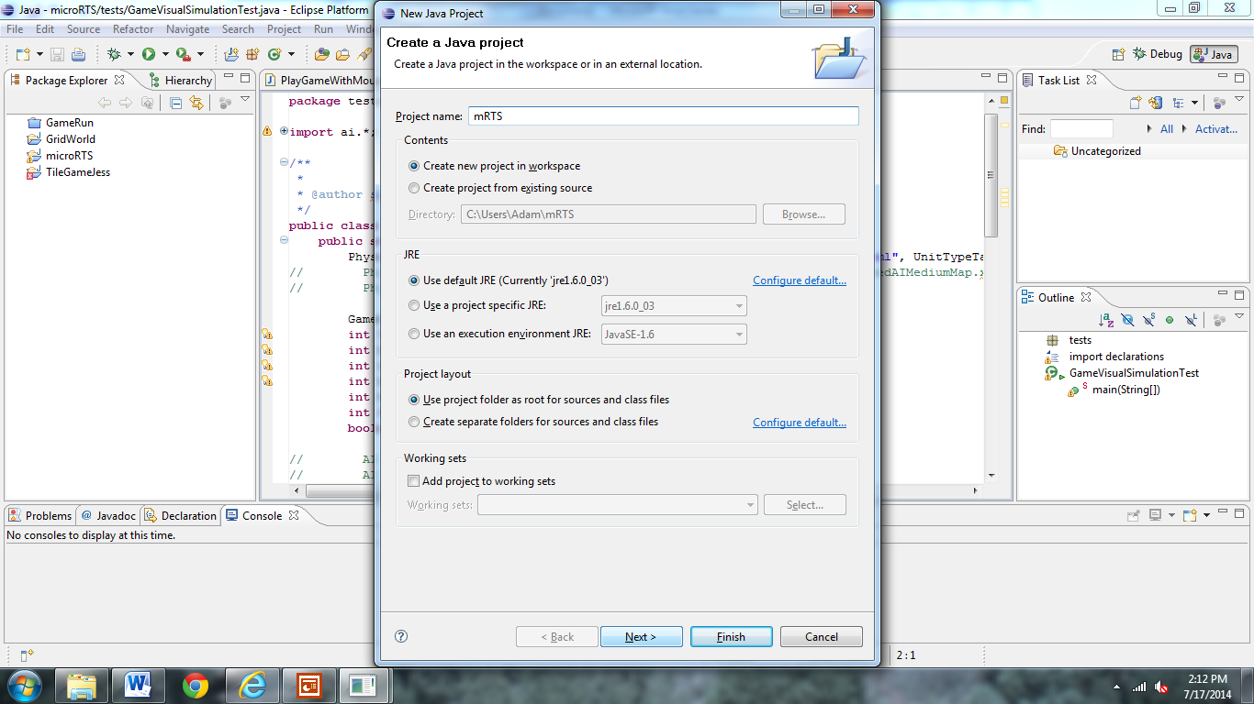

Name your file and make sure the corresponding buttons are selected. Select Next.

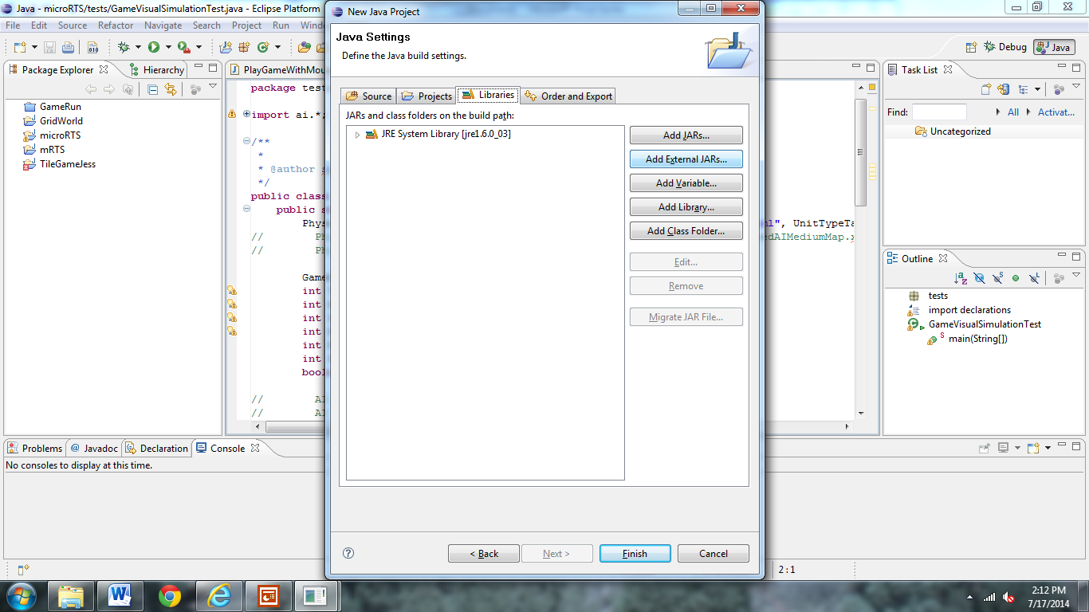

Select Add External JARs and locate the Jdom file on your computer. Select the file then press finish.

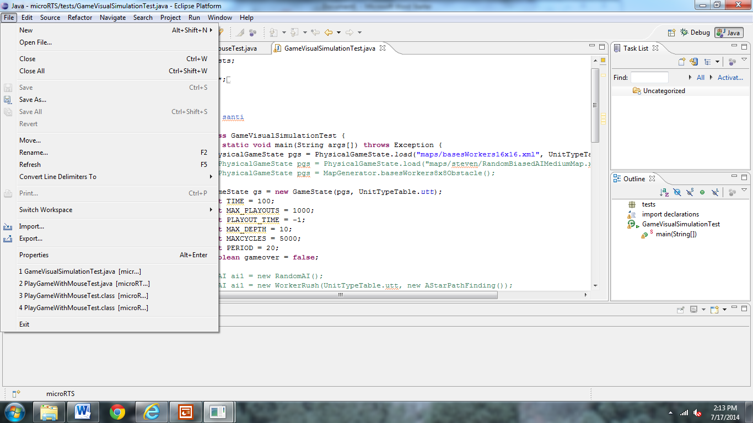

Click on your project then file then import.

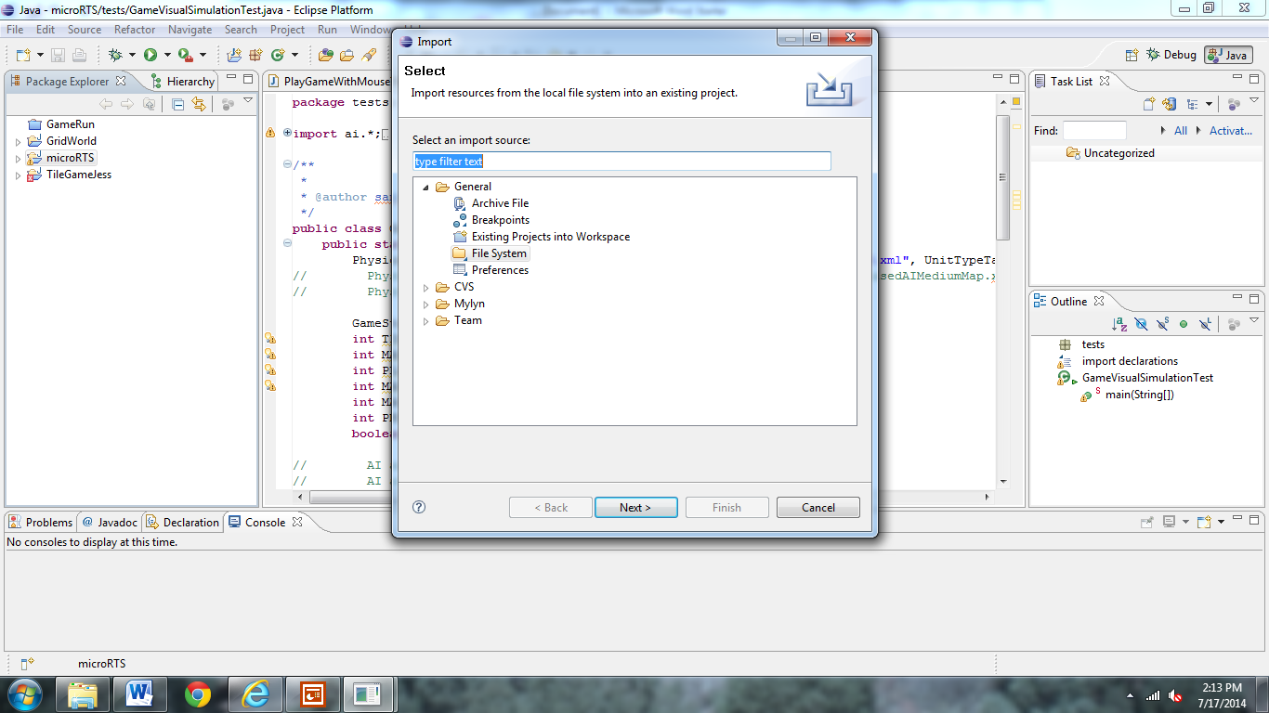

Select General- File System - Next

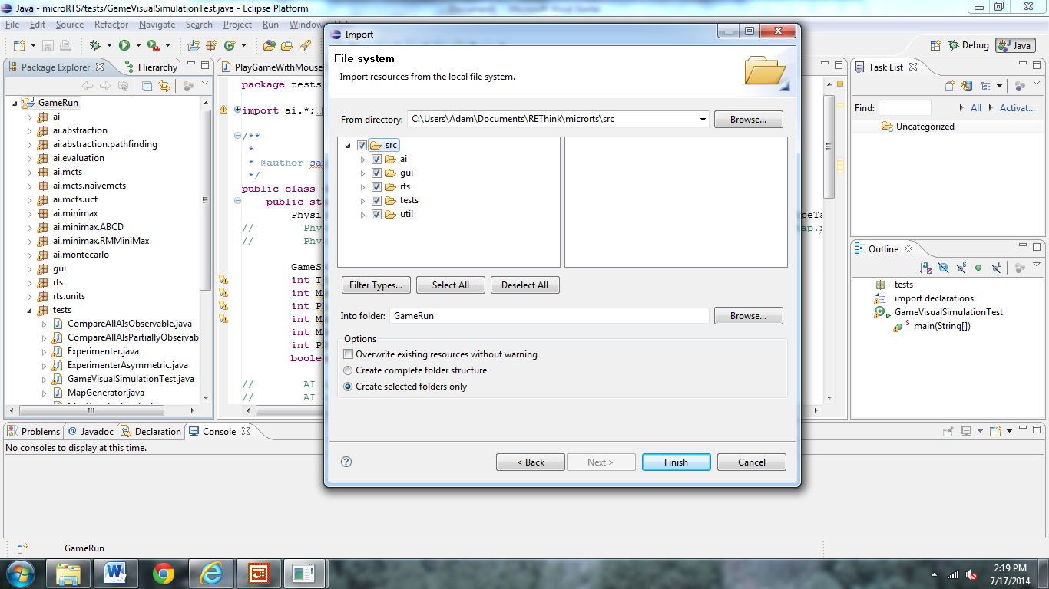

Browse – locate where you saved microRTS source code when using TortoiseSVN – select src code folder, check all boxes, and select finish.

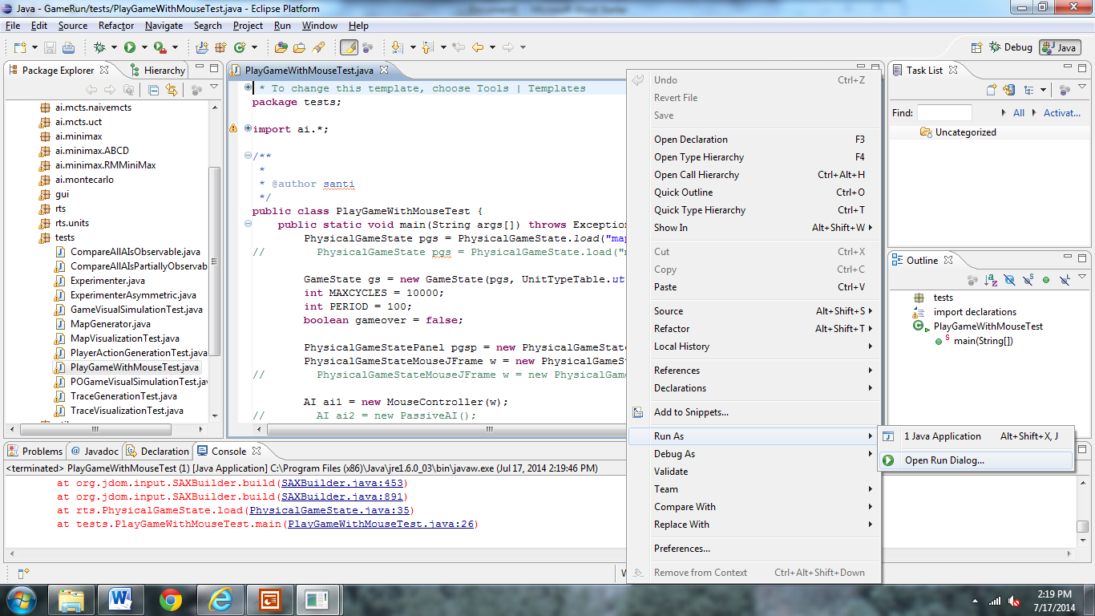

In the test folder open PlayGameWithMouseTest file. Right click in file, select run as, open run dialogue box.

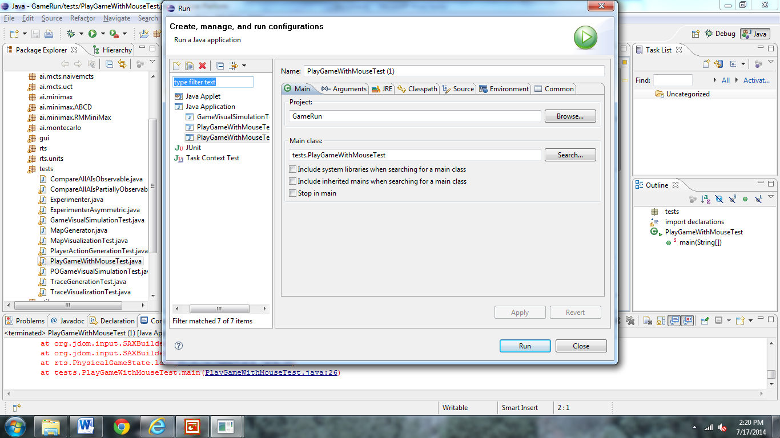

Step 2: Select the Arguments Tab

Step 1: If necessary select Java application. Make sure it is the right project name and the correct main class.

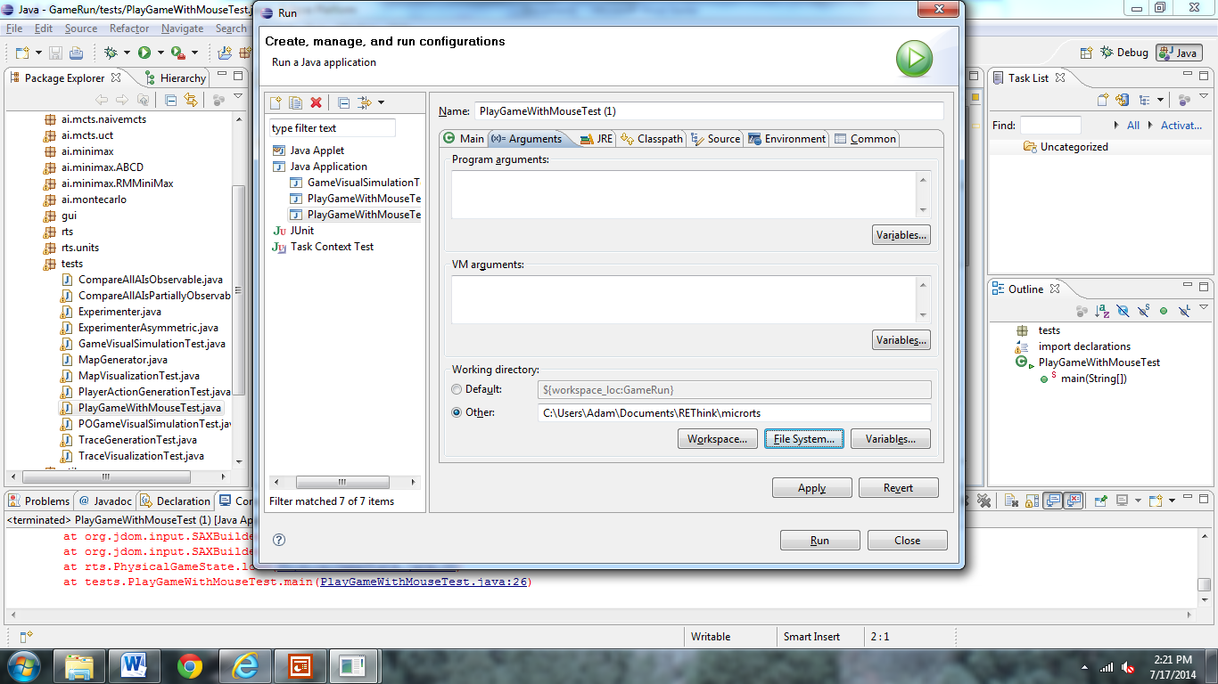

Select Other Button – File Systems – locate where you saved microRTS (entire folder not just source code this time) when using TortoiseSVN and select that file – select run and your game window should open. **\*\*Every time you open a new type of test game, you might have to complete this and the previous step to make sure the working directory is correct. Otherwise your game may not run.**